Module 4:
Encryption
The program CCleaner was located on the computer. Answer the following questions about the program.

What web site did the user download the program from and what is the end date/time of the download?
The user downloaded the program from https://bits.avcdn.net and the end date/time of the download was 9/12/2022 12:26:01.000 PM
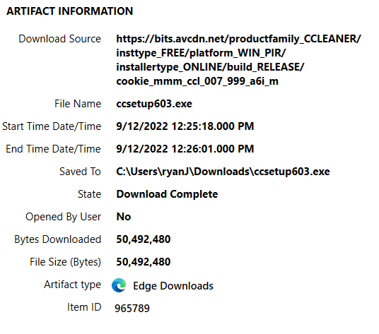
What web browser was used to download it?
The web browser that was used to download it was Microsoft Edge


How did the user locate the web page for download and what search engine was used?
The user located the web page by making various searches related to “ccleaner” using the Bing search engine.
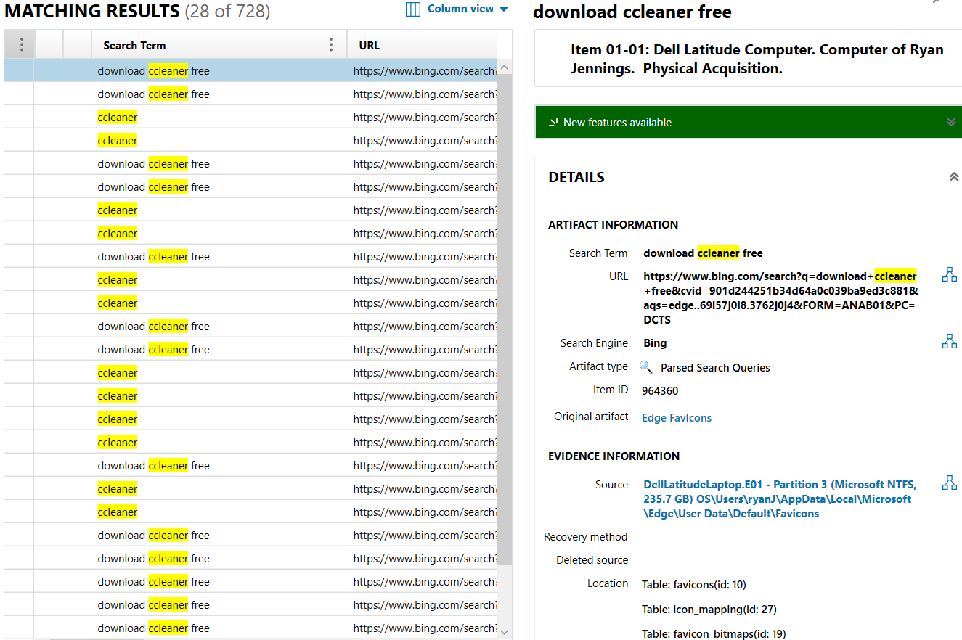
When was the last time that the program Ccleaner64.exe was run?
The last time that the program Ccleaner64.exe was used is 9/13/2022 12:49:27.179 PM.
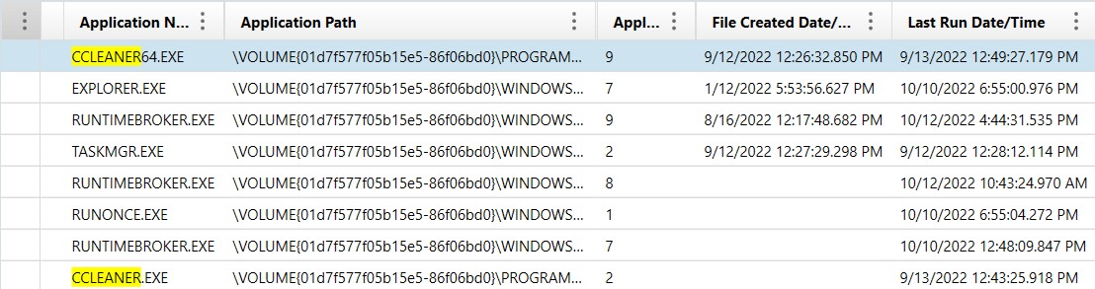

The program TOR was also located on the computer. Answer the following questions about the program.
Where is the program TOR saved on the computer?
The Tor Browser is saved under ryanJ’s OneDrive Desktop.
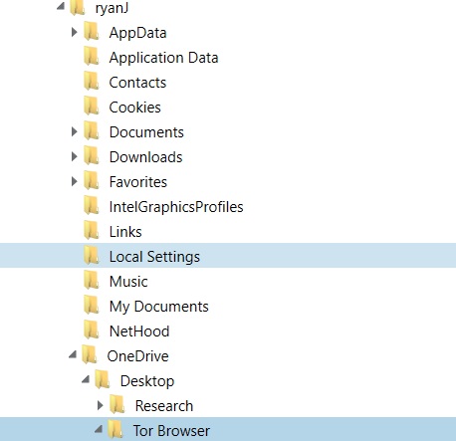
Has TOR ever been run? If so, when was the last time it was run?
Yes, TOR has been run, the last time TOR was run was 9/12/2022 12:37:06.628 PM
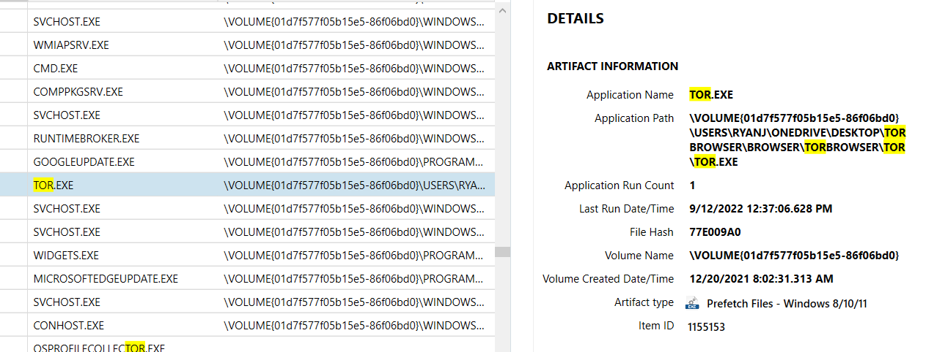

What search activity is there on the computer five minutes prior to and after TOR was run?
Five minutes prior to TOR being downloaded, there was a search made on the computer asking “where can i download tor[”. Five minutes after tor was opened, the user launched VideoLAN Client (VLC) as well as “NEWS.txt” and “vlc.exe” through VLC.
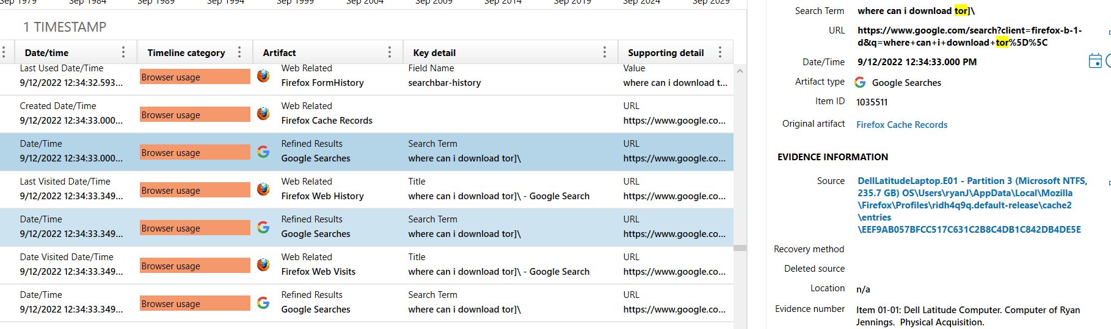
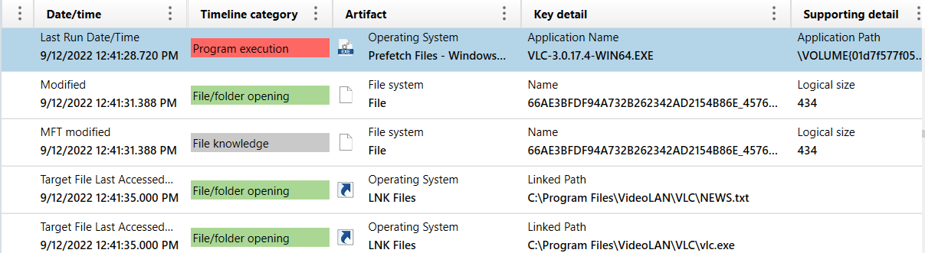
Are there any .onion Tor URL’s on the computer? If so, can you tell the type of web page?
Yes, there are many .onion Tor URL’s that are on the computer. One specific web page that was found is the “Hidden Wiki,” which is bookmarked on the Chrome browser.
